W02 Group Project: Setup, Planning, Theme, and Component Design
- Summary of the meeting. Keith Eberhard, Myself (Jim Eberhard), and Miguel Ignacio Arcos Salazar were in attendance. At the last minute Kevin Garcie Ferreira had a family emergency so we recorded the session so he could watch it later. Also, Mbuyazwe France Dube also watched it later to get caught up. We talked about what we would like to see for this website. It was decided that it would be similar to Ebay or Etsy. We talked about the different features it would have (some of it listed below in item 5). The website will allow users to upload their products, showcase them, and sell them and track reviews.
- 2. The group project URL:
- https://github.com/Stratoverus/handcrafted-haven
- Screenshot of clone onto my machine: 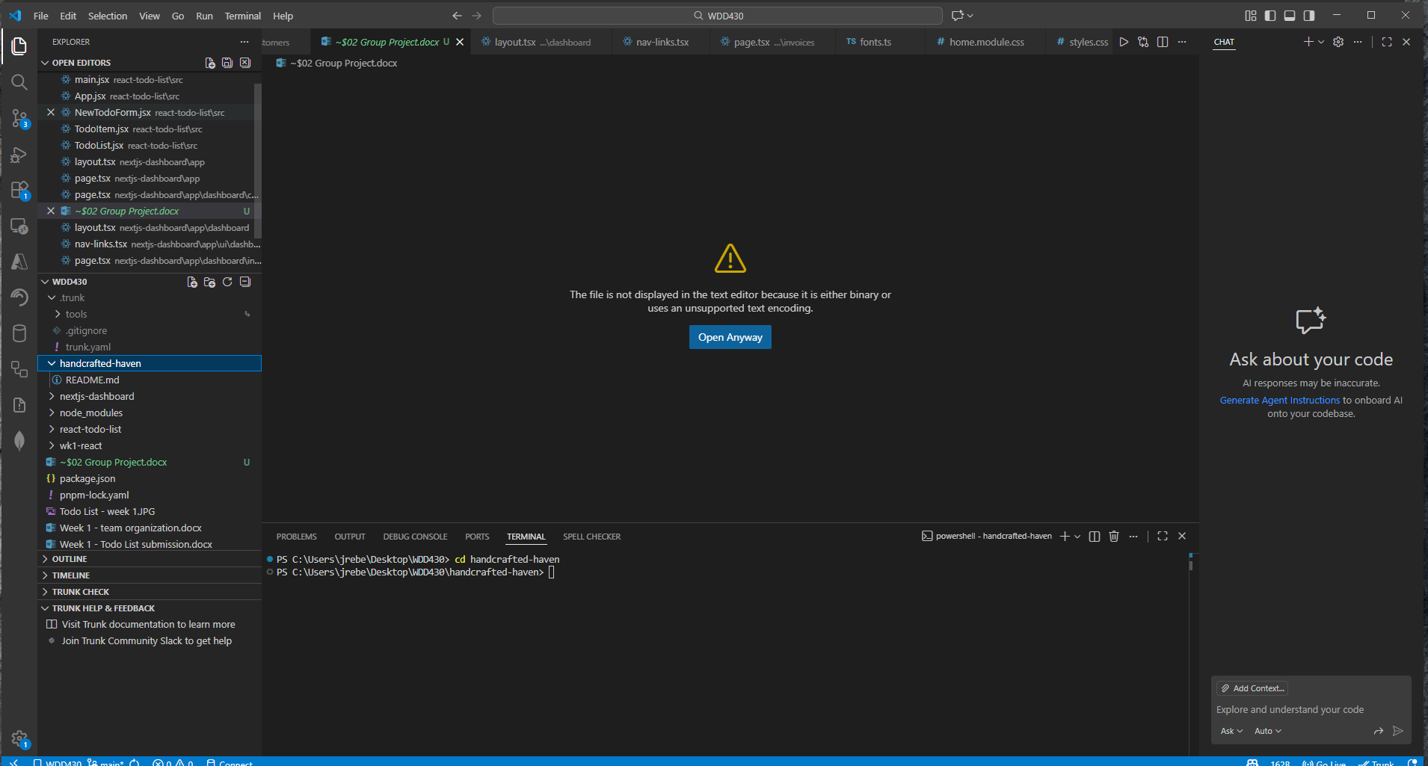
- Design Theme of the project – Home Page: 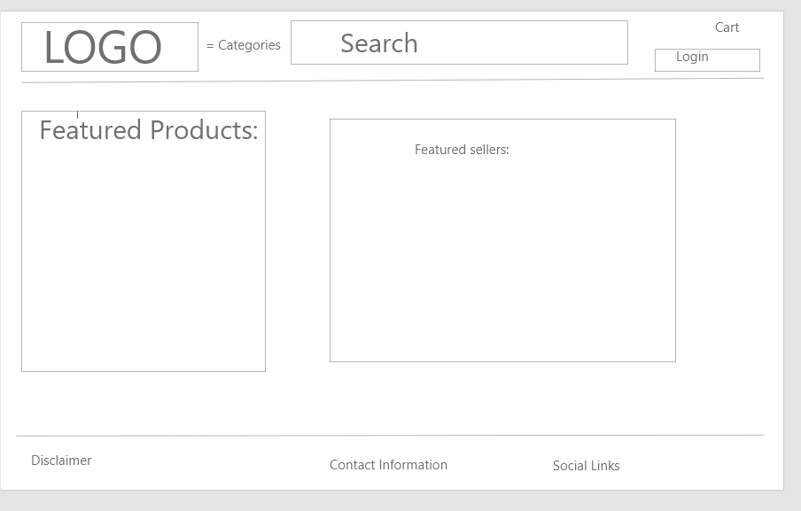
  - Color schema https://coolors.co/050517-cf5c36-efc88b-f4e3b2-d3d5d7
  - Fonts: Title/Heading Font: Roboto ---- Text Font: Open Sans
- Brainstorming: https://github.com/users/Stratoverus/projects/1
  - Home Page Setup
  - User Profile Page – will have order history, favorites, reviews given
  - Browse Products Page – browse by category or by seller
  - Template for Individual Product Page/Listing – will list the product with description, price, seller, est. shipping.
  - User sign-up page – users must sign-up to make a purchase
  - Publicly Accessible seller profiles
  - User Login Page/popup
  - Product Review – will list the product you are review and have a entry box to leave a review.
  - Review Seller- be able to give a rating on the seller.
  - Message Seller – have a way to message the seller
  - Authentication for user space
  - Shopping Cart Page – lists what is in the shopping cart and from what seller
  - Search Bar Functionality – search by item, seller, category
  - Seller Dashboard Page – will allow the seller to edit, list, alter item in their ‘shop’.

